Jenkins-1
1) Install Jenkins and run Jenkins on port number 8081.
Step-1. Install Java
(Jenkins requires Java)
sudo dnf install -y java-17-amazon-corretto
Verify java
java –version
Step-2. Add Jenkins Repository
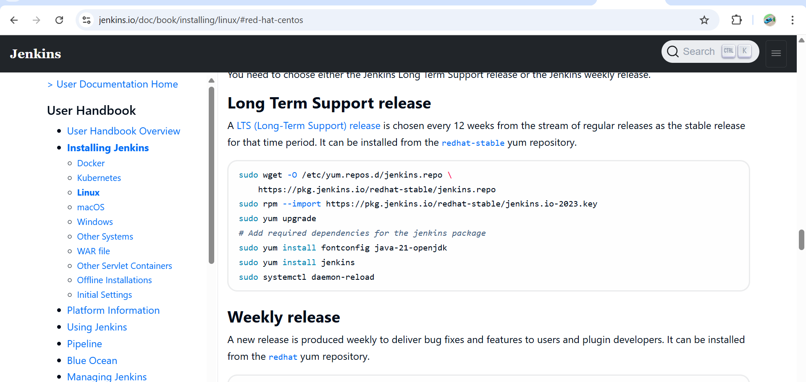
sudo wget -O /etc/yum.repos.d/jenkins.repo \
https://pkg.jenkins.io/redhat-stable/jenkins.repo

sudo rpm --import https://pkg.jenkins.io/redhat-stable/jenkins.io-2023.key

Install Jenkins
sudo yum install -y Jenkins

Start and Enable Jenkins Service
sudo systemctl start jenkins
sudo systemctl enable Jenkins
Check status:
systemctl status Jenkins

Step 3: Change Jenkins Port to 8081
By default Jenkins runs on 8080, so we edit its systemd config:
Now go to → sudo vi /usr/lib/systemd/system/jenkins.service
Update → Environment="JENKINS_PORT=8081"

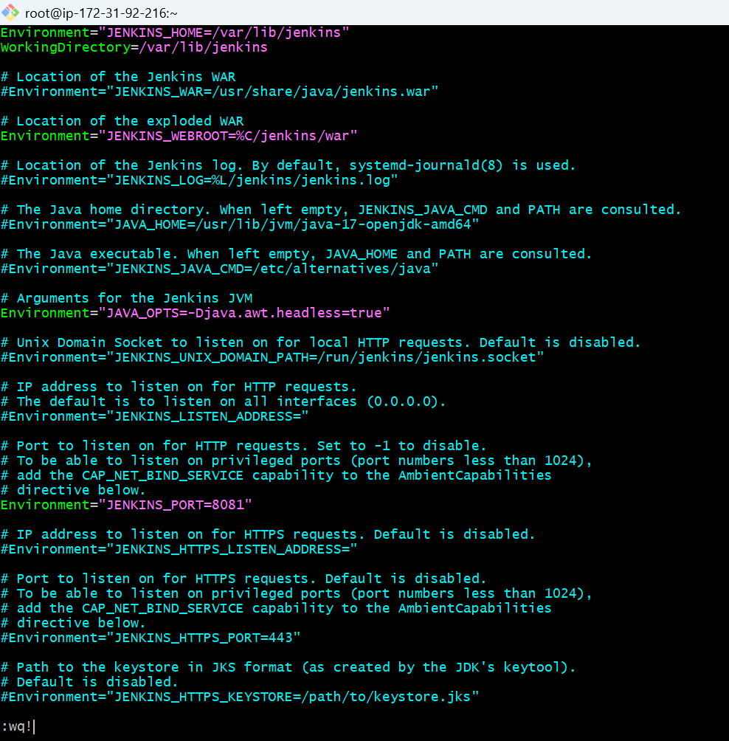
sudo systemctl daemon-reexec
sudo systemctl daemon-reload
sudo systemctl restart Jenkins

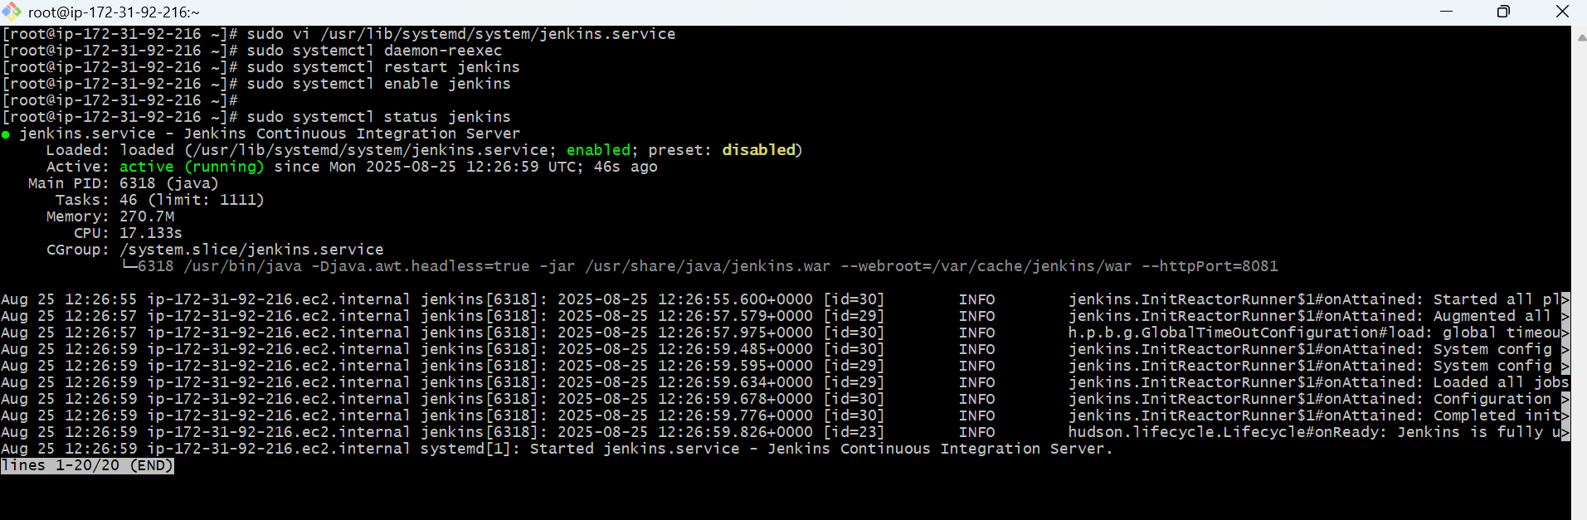
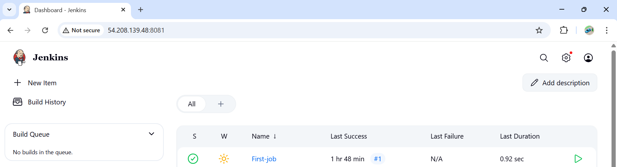

2) Secure Jenkins server

Securing Jenkins Server
Step -1. Change Default Admin Password
First login: Jenkins asks for the initial admin password
/var/lib/jenkins/secrets/initialAdminPassword
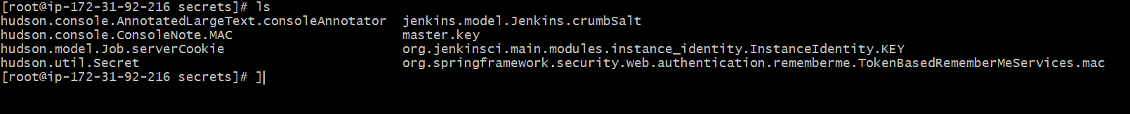
Create a new admin user, then disable or delete the default admin if possible.

3) Create users called DevOps, Testing in Jenkins with Limited access.
Create Limited Access Users in Jenkins

Step 1: Install Role-Based Authorization Plugin
- Go to Manage Jenkins → Plugins → Available Plugins.
- Search for Role-based Authorization Strategy and install it.
- Restart Jenkins after installation.

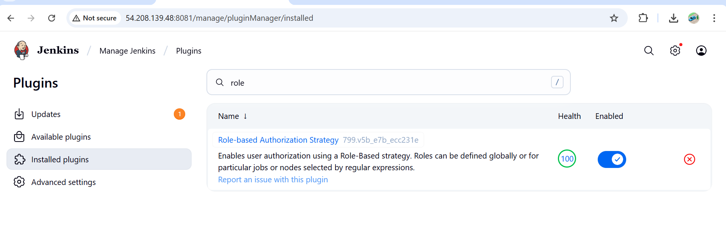

Steps to Create Users in Jenkins
- Log in to Jenkins as an administrator.
- From the left menu, go to:
Manage Jenkins → Security → Manage Users.
- Click Create User.
- Enter details for each user:
  - Username: DevOps
  - Password: (choose a strong one)
  - Full Name: DevOps
Repeat for user Testing.
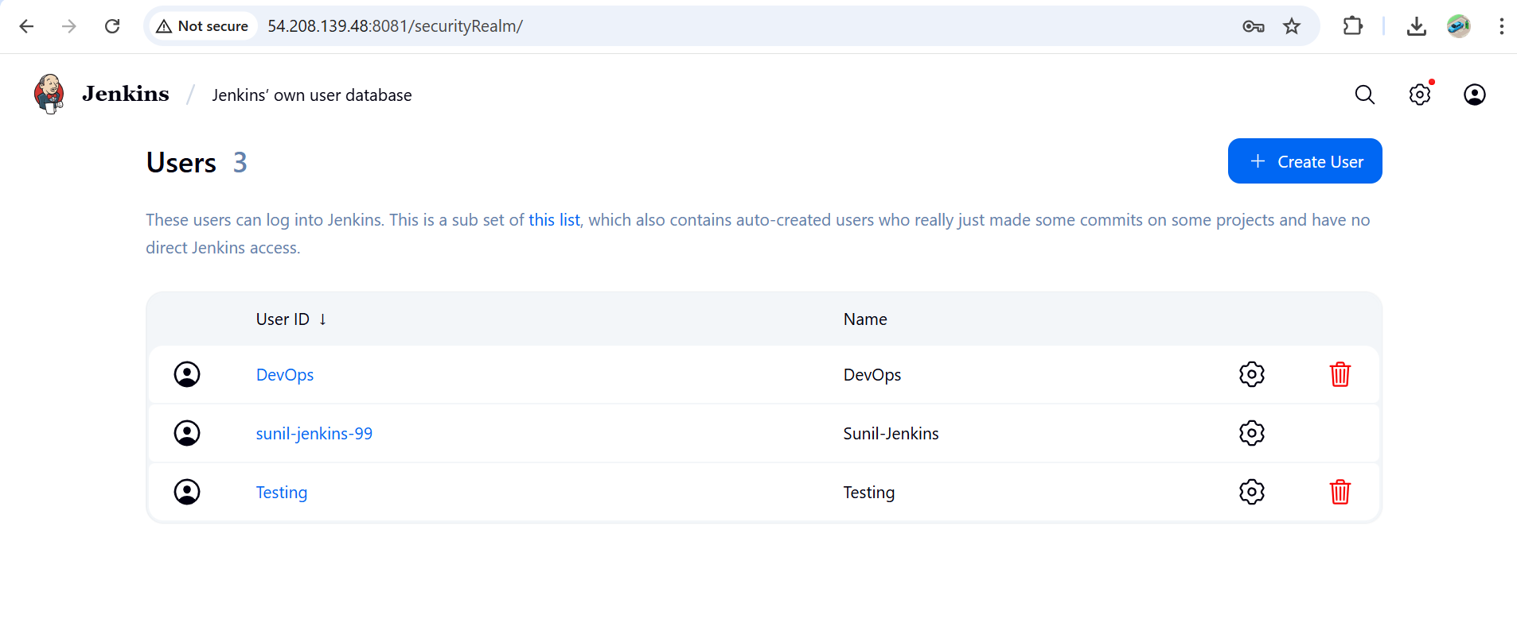
After creating users
Go to
Manage jenkins – security
In authorization select –project based matrix
And give the limited access
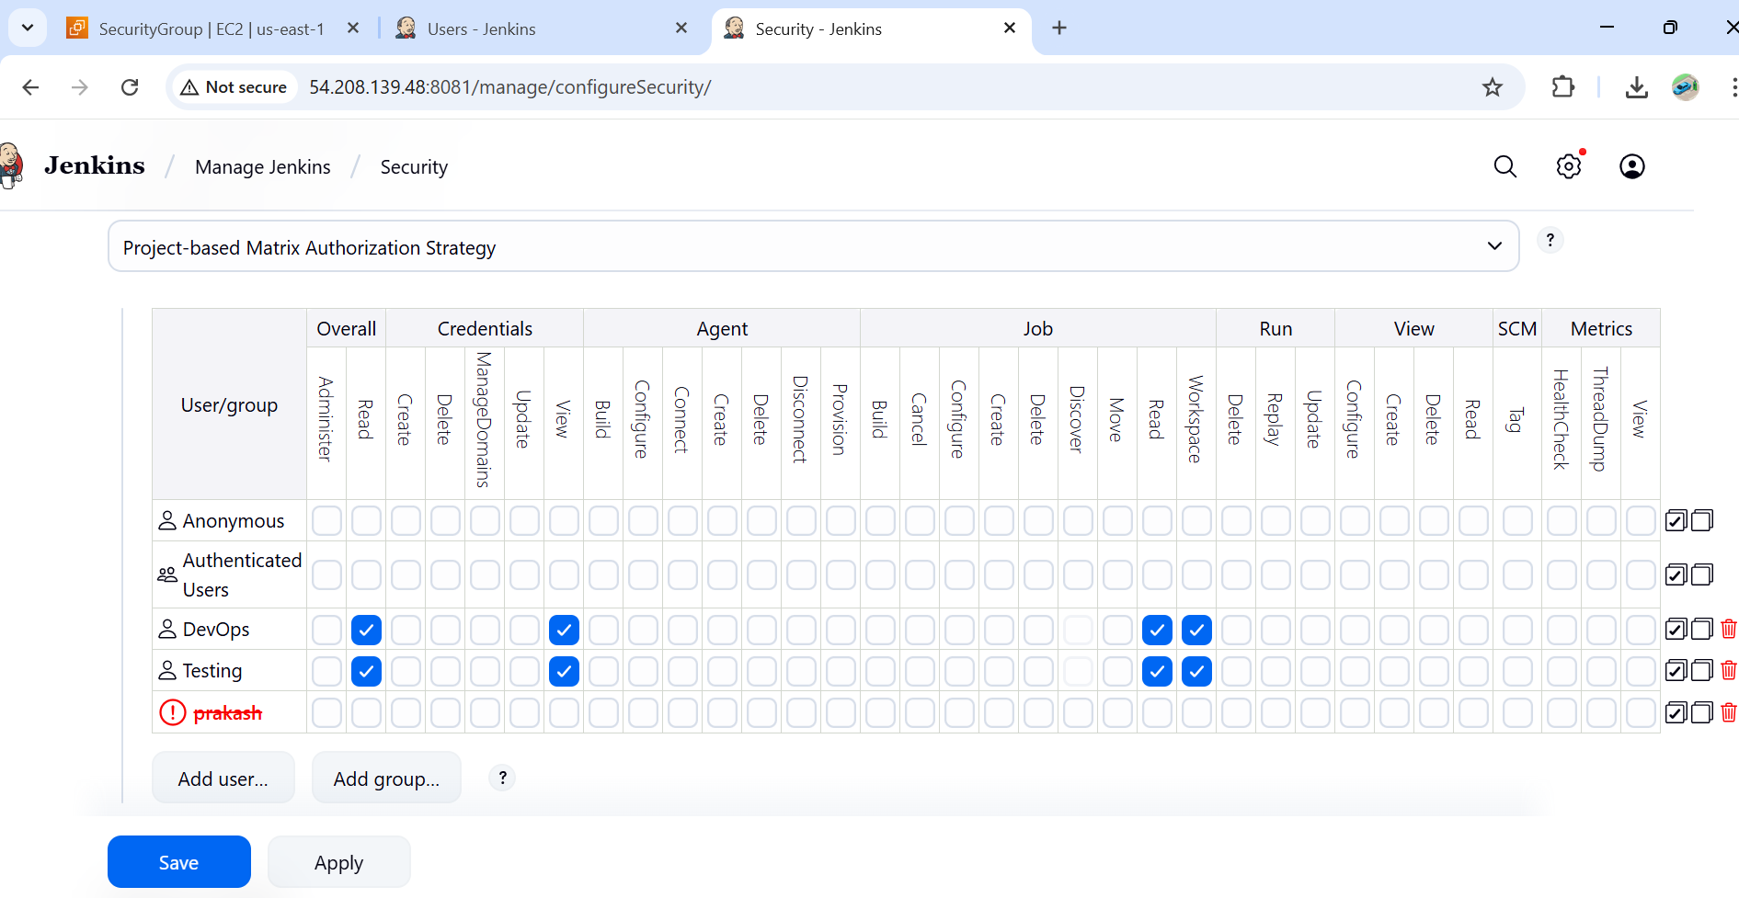

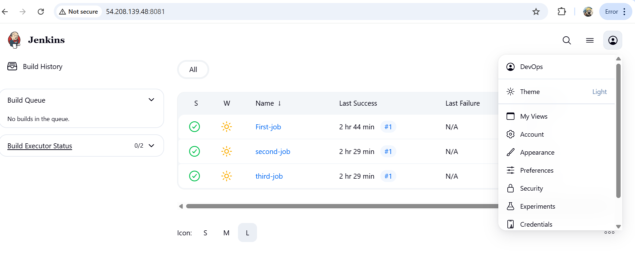
4) Configure labels and restrict the jobs to execute based on label only.
Step 1 : Assign Labels to Nodes
Go to manage Jenkins – system
In labels give any label name

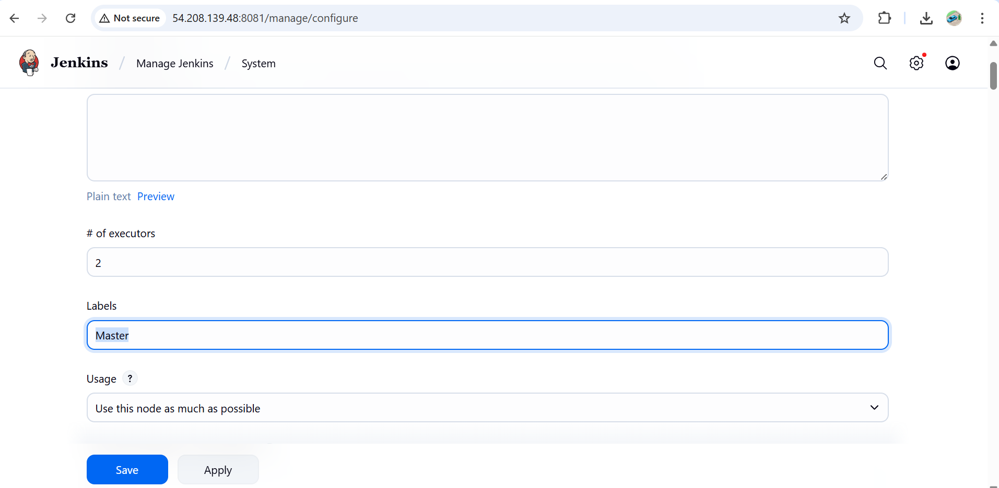

Step 2: Restrict Job to Run on a Label
- Open the Jenkins job (Freestyle or Pipeline).
- Click Configure.
- Under General, check Restrict where this project can be run.
- In the text box, enter the label (e.g., Master).
- Save.
Now this job will only run on nodes with that label.
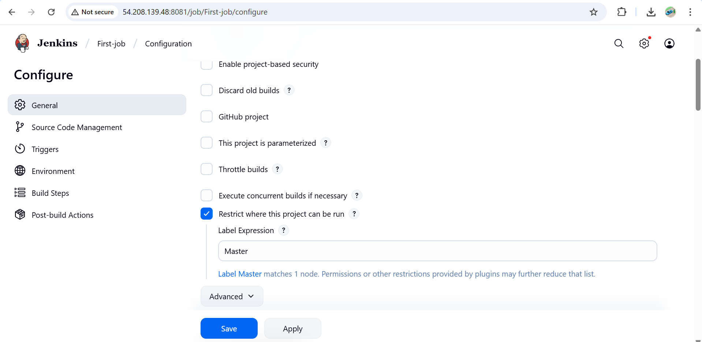

5) Create Three sample jobs using the below URL. https://github.com/betawins/Techie_horizon_Login_app.git
Step 1: Pre-Requisites
Jenkins server should have Git installed
yum install git
(git --version).

Step 2: Create 3 Sample Jobs
Job 1:
Go to New Item → Freestyle Project → Name: Sample-Job-1.
Under Source Code Management → Git, enter repo URL:
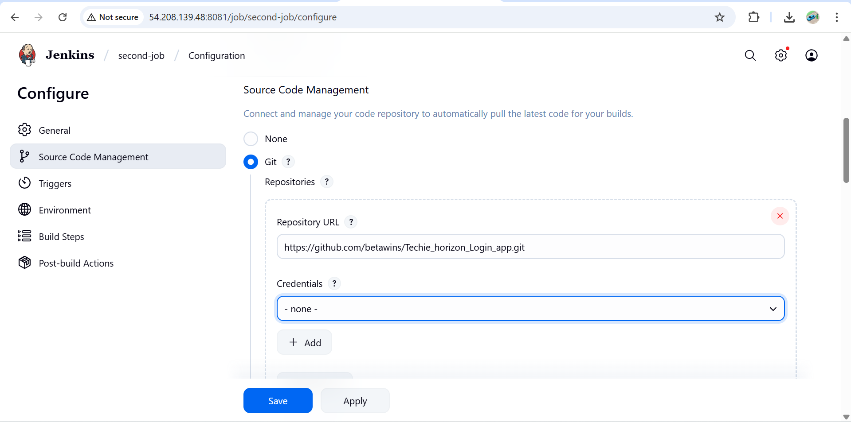
Save & Build.
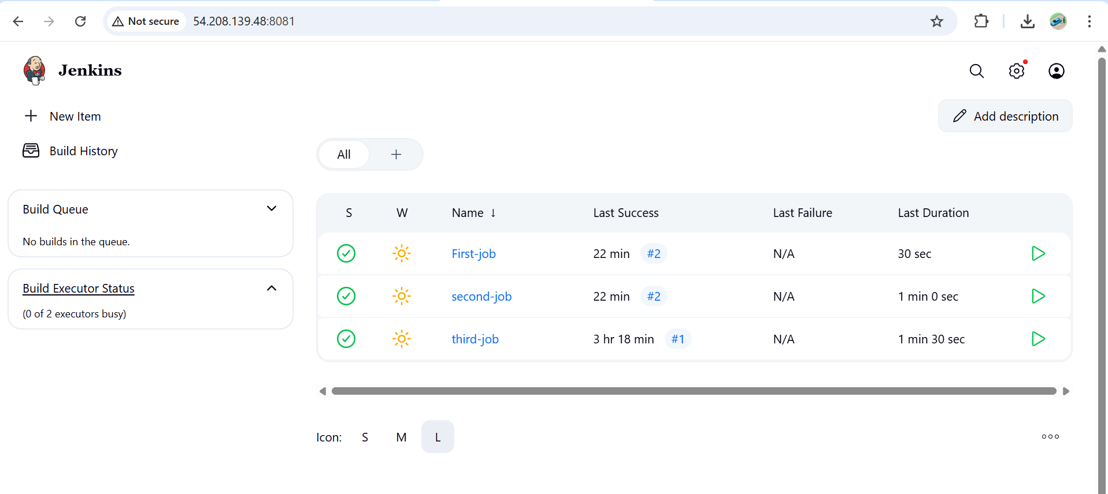
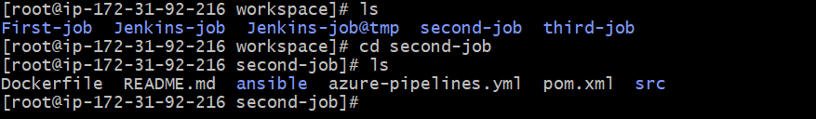
6) Create one Jenkins job using git hub Private repository.
Step 1: Generate GitHub Credentials
- Go to GitHub → Settings → Developer settings → Personal Access Tokens → Tokens (classic).
- Generate a token with permissions:
- Copy the token.
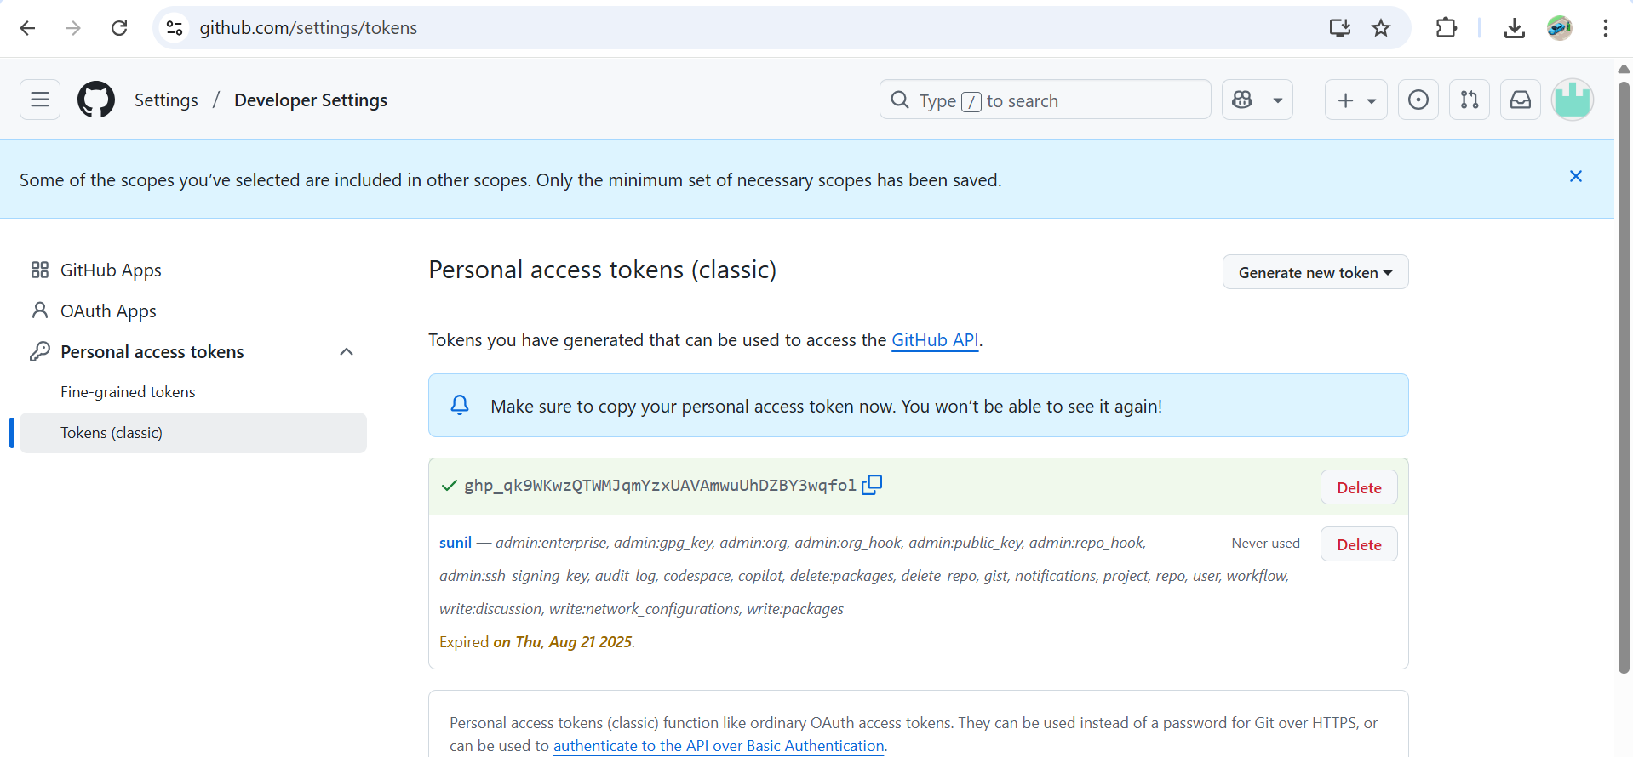
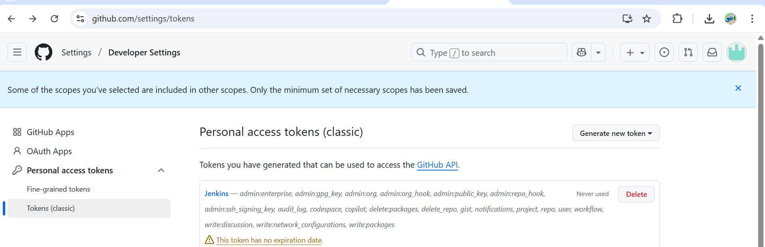

Step 2: Add Credentials to Jenkins
- In Jenkins → Manage Jenkins → Credentials → (Global).
- Click Add Credentials:
  - Kind: Username with password
  - Username: GitHub username or token
  - Password:
  - ID: github-private (ex)

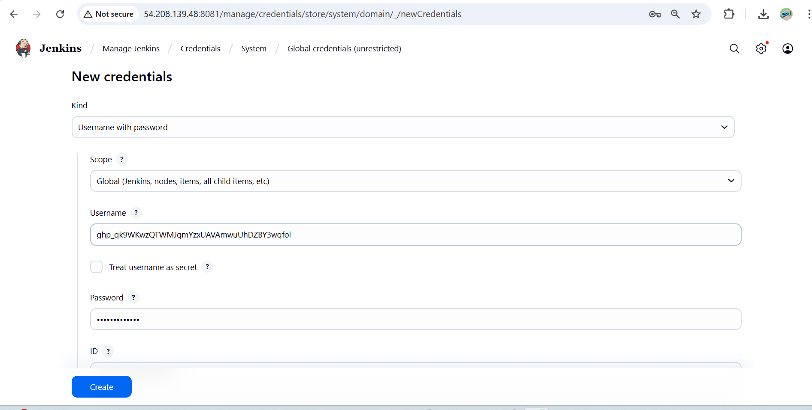
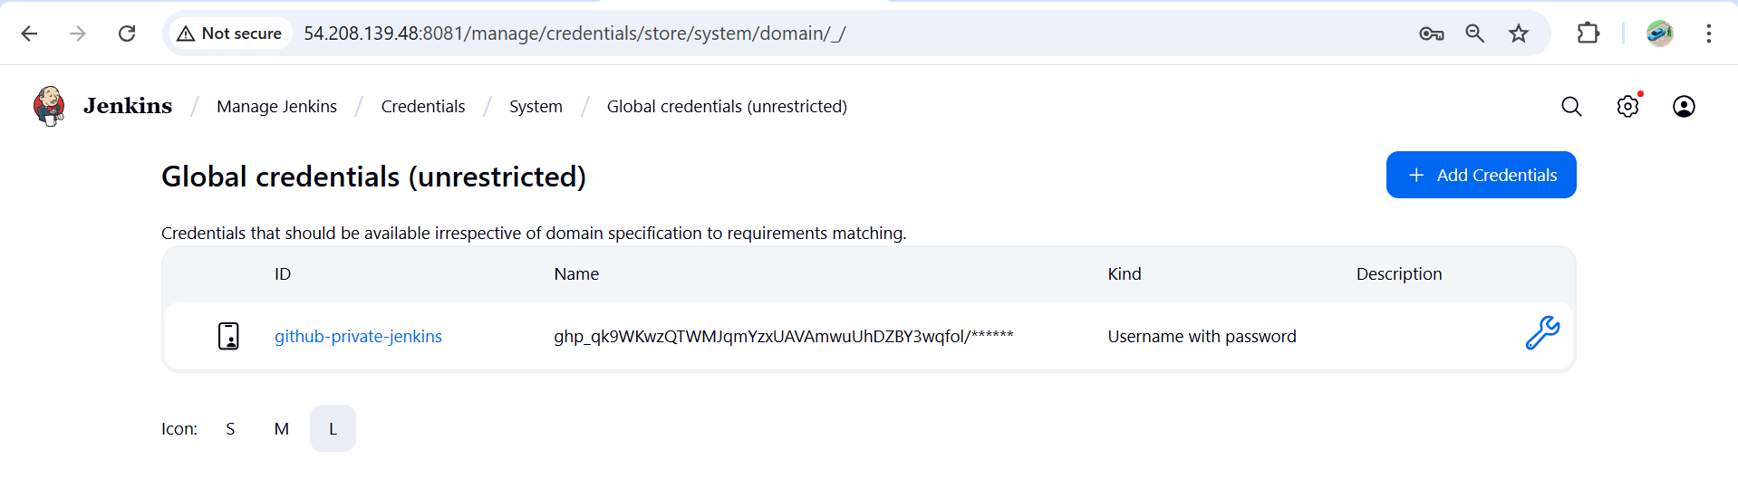

Step 3: Create Jenkins Job
- New Item → Freestyle Project → Name: Private-Repo-Job.
- Under Source Code Management → Git:
  - Repository URL:
